**QSMART – PUMP CHAMBER REPLACEMENT**

**PROCEDURE**

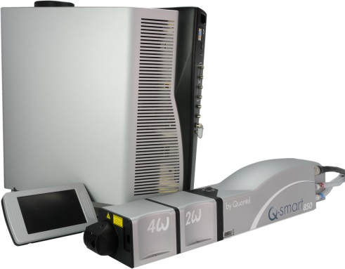

**Toolkit:**

Metric Allen Keys

Special tool for interlock cover head RM100016A

Special tool SM020006A for software update

Ethernet cable

Powermeter

Scope and photodiode

Burn paper

**System**: QSMART

|  |  |  |  |  |  |  |  |  |  |  |
| --- | --- | --- | --- | --- | --- | --- | --- | --- | --- | --- |
| |  |  | | --- | --- | | SM010340  SM010341 | **PUMP CHAMBER W OPT**  **PUMP CHAMBER W OPT S/E** | | | | | |  |  |  |  |
|  | | | | |  |  |  |  |
|  |  |  |  |
|  |

**Purpose**: This procedure describes the integration of the complete pump chamber of a QSmart

|  |  |  |
| --- | --- | --- |
| Revision | date | modification |
| Initial issue | July 4, 2014 |  |
|  |  |  |
|  |  |  |
|  |  |  |

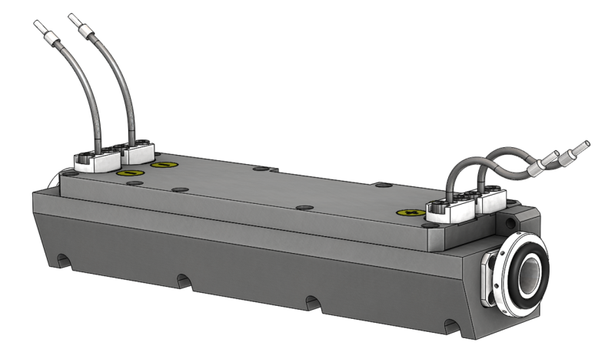

# DISASSEMBLING

* Turn the system off
* Disconnect cables and water hoses from the side of the laser head side
* Remove the laser head cover.
* Remove the side plate (7 BHC 3x6)

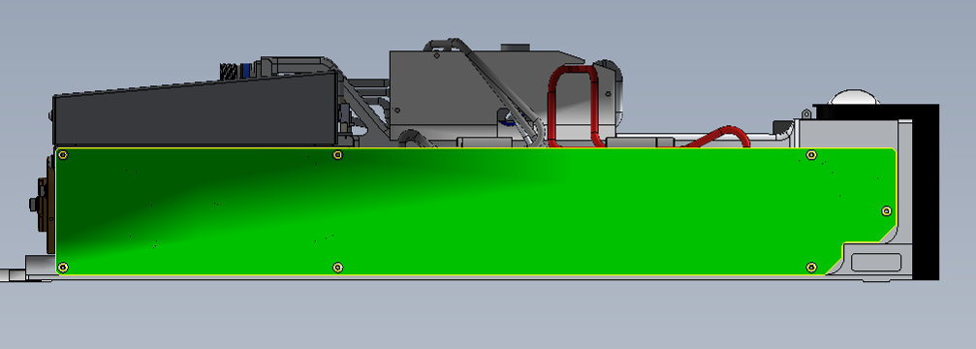

* Disconnect the flash lamp cables on the TRIGGER card

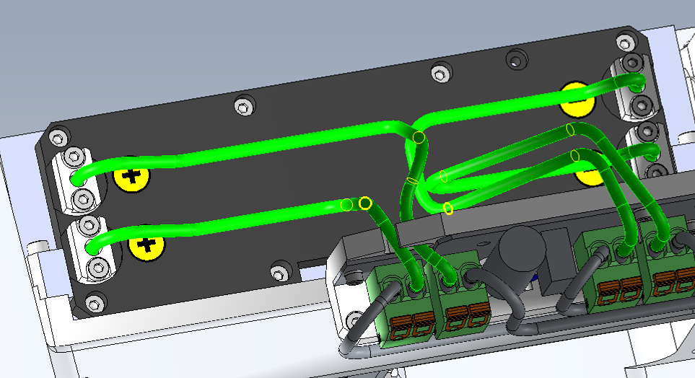

* Unscrew the 2 O-rings located on both sides of the pump chamber
* Remove the screw which maintain the cable coming from the TRIGGER card on the pump chamber
* Remove the pump chamber ( unscrew the 4 screws )

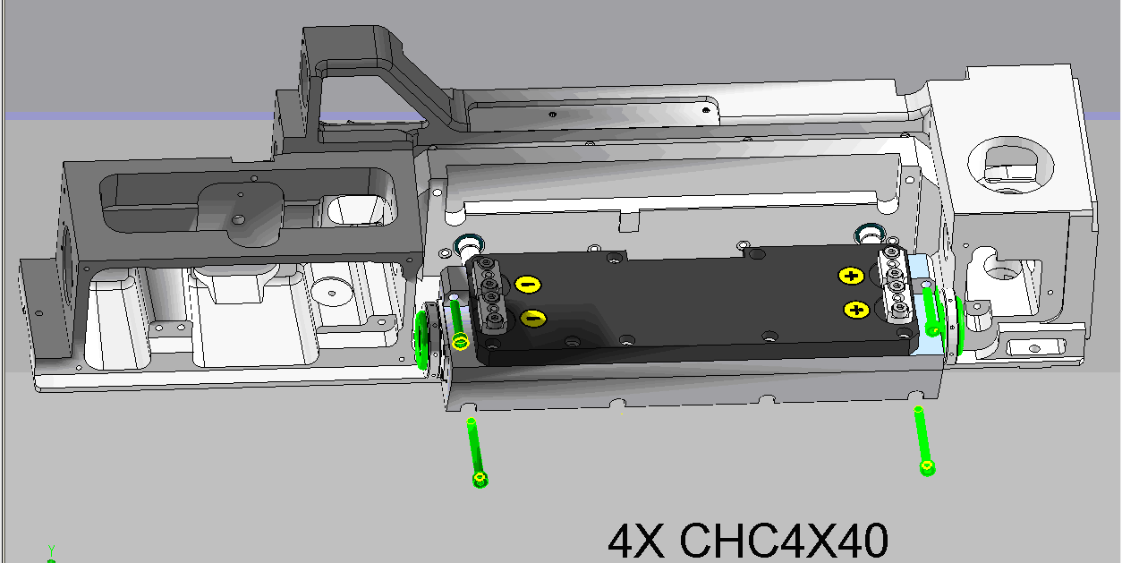

3/E10/0666 O-rings

3/E10/0353

O-rings on the water main

# Installation of the pump chamber

* Place the optical head on an optical table
* Add 3 mounting feet in order to fix the Laser head to an optical table
* Place two O-rings D20 C4 (3/E10/0666) at the extremity of the pump chamber and 2 others rings (3/E10/0353) on the water main.

Be careful, the highest screws are the shortest screws and the lowest screws are the longest.

* Adjust the O-rings of « sealing dust », put in touch the O-rings with the body



3/E10/0666

* Plug the lamp flash cable on the TRI board



* Screw the cable of the TRI board on the pump chamber (CHC 3x6 + ZU3 washer)

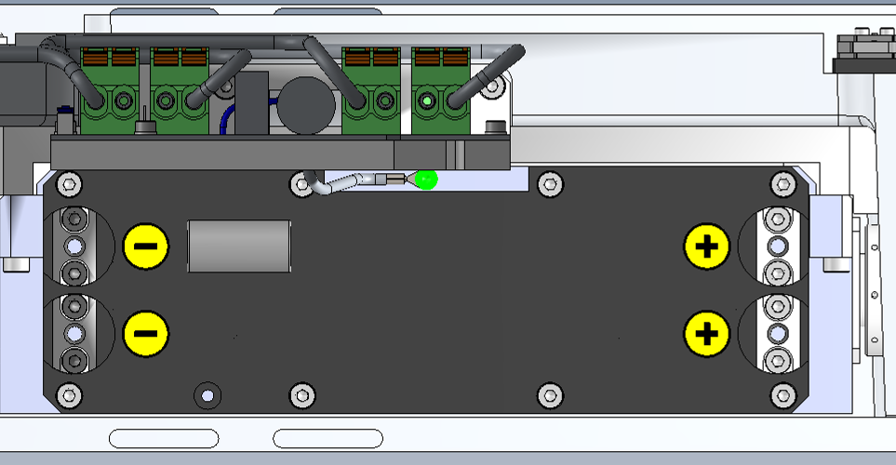

The pump chamber is now re-assembled

# ADJUSTMENT OF THE LASER (Spiricon or Burn Paper)

*Refer to Laser Adjustment procedure.*

* Close the Laser head and put warranty stickers   
  *Refer to "LH-Warranty Labels"*